After five months, we have finished the Cromarty Bunting Project!
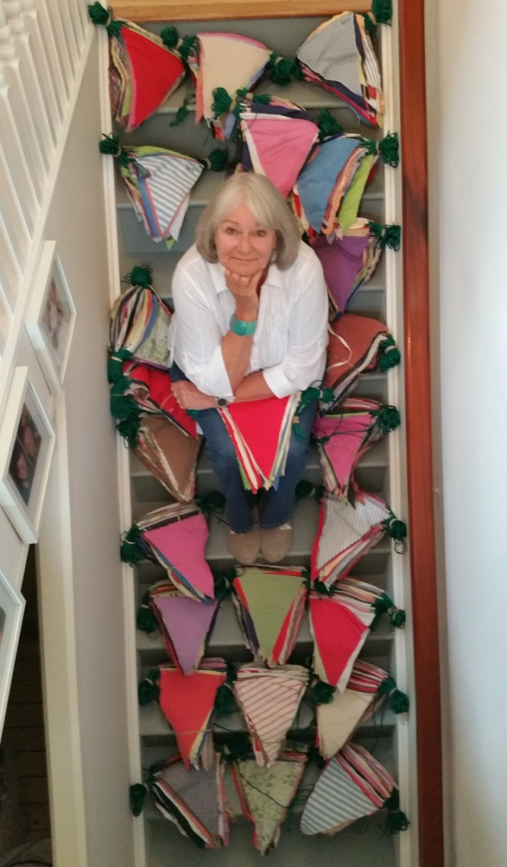
Before I thank all those involved,
I’d like to detail a few statistics.....
We’ve cut out 2,500 pennants
Used 2,200 metres of sewing thread
Sewed 85,000 inches of stitching
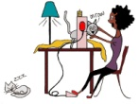
And created 1200 metres
– That is just about ¾ mile! –
Of Fabulous Cromarty Bunting!
So, heartfelt thanks go out to -
Dorothy “Don’t stop me now” Penn, Jane Dunn, Jo Donald, Ann Dickie, Jane Hale, Christine Cameron,
Fiona Marie Macdonald, Cromarty Youth Cafe,
-and to all of you who so kindly raided your homes for fabrics-
We couldn’t have done it without you!

Vivienne Plampton, July 2016

